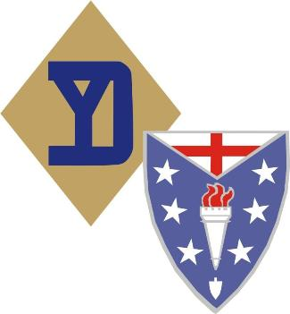
COMPANY “B” DISPLAY EVENT S.O.P.

The following procedures will be followed and complied with as of 9-12-2009

Whenever Company B 104th Inf. 26YD attends a Display or Timeline event. Those unit personnel who do not set up a display will be assigned to and rotate through each of the company display’s at the event during the hours of event operation by the 1st Sgt. or the NCOIC, for a period of 1-2 hours in each company display, So that they can assist with the display presentation and learn about the display’s so that all unit personnel will eventually be able to:
- Explain what is being displayed to the public spectators or other members of Company B.
- Explain how it was used by the WWII Infantrymen, to the public spectators and other members of Company B.
- If needed demonstrate or help demonstrate how items on display were used by the WWII Infantrymen, to the public spectators and other members of Company B.
- Allow for display presenters-owners to be able to leave the display in capable hands so that they can get something to eat, drink, take a break and have some time to see what else is at the event during the hours of event operation
- Become knowledgeable through on the job training on and about the weapons , equipment, uniforms, to include the usage of the items on display in the company display area

Those extra members of Company B, who are in attendance at the event and are not assigned to a display presentation initially, will be assigned to perform a walking display for 40min –1hr in and around the event grounds in order to:
- Make contact with the public spectators,
- Answer questions about what they represent and what they have on
- Let spectators know were they can find the Company “B” display area and if interested learn how to join the 26YD.
When the 40min-1hr walking tour of duty is completed, they will then rotate into one of
The displays or be given another task by the 1st Sgt. or NCOIC until they can be rotated into one of the displays for the 1-2 hours of on the job training process.

This SOP will be followed throughout the operational – open to the public portion of each day that Company “B” is in attendance at the Display or Timeline event.

Guy Mazzarella
Guy Mazzarella, 1st Sergeant
Company B, 104th Infantry Regiment
Adjutant

