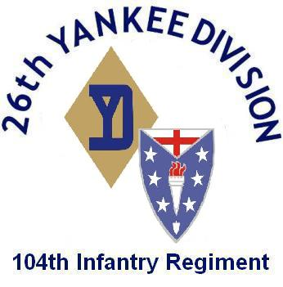
Company B 104th Infantry
26th Infantry Division
Fort Devens, Ma

Order No.

To: Hq Coy B. 104th Infantry Regiment
Subject: Promotions

George E. Devlin.

George E. Devlin,
Captain, 104th Infantry,
Commanding.
Copy To:
Personnel, Clerk

