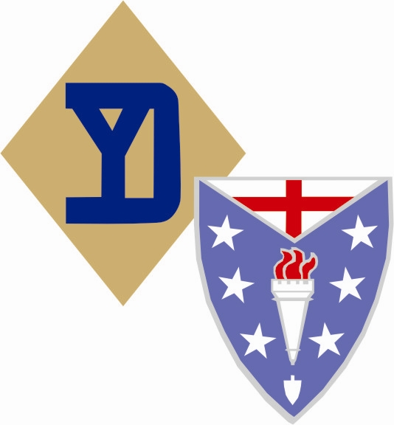
Baker Company Awards, Decorations & Qualifications
B Co. 104th IR 26th ID HRG

American Defense Service Medal Ribbon: For successful attendance of 3+ Living History displays in one re-enacting year.

Women's Army Corps Service Medal Ribbon: For female member attendance of 7+ events (awarded after 1 year of unit participation).

American Campaign Medal: For unit member attendance of 7+ training events (awarded after 2 year’s of unit participation).

Asiatic-Pacific Campaign Medal Ribbon: For unit member participation in 3+ Pacific Theater Tactical’s.

European - African - Middle Eastern Campaign Medal Ribbon: For unit member participation of Ft. Indiantown Gap and / or Reading PA event with the unit. Or at least 7 ETO Tactical events. (Maximum of 4 battle stars, for each aforementioned GAP/Reading event listed).

World War II Victory Medal ribbon: For completion of 3 years of active member service in the 26YDHRG.

Army of Occupation Medal ribbon: For successful completion of 4+ years of active membership. Must be awarded by the unit Commander only.

WW1 Victory medal Ribbon: For successful completion of 5+ years Active service in the 26YDHRG & above age 45. Must be awarded by the Unit Commander only.

WW1 Occupation Medal Ribbon: For Successful completion of 5+ year’s active membership with at least 1 in a leadership position and above the age of 45. Must be awarded by the Unit Commander Only.

Mexican Service Medal Ribbon: For 10+ years of service, age over 45, prior military service & held a leadership position.

Mexican Border Campaign Medal: Awarded to members of the 26YDHRG over the age of 45 for 15+ years membership. Note: Member must not have held a leadership position. Authorized and awarded by the Unit Commander only.

1.

Marksmanship badges: Are worn if you earned them through the unit.

We have live fire practice at a firing range at least 2-3 times a year.
Scores are posted following.
You are required to come to at least 1 and shoot for score to earn these badges.

Service stripes: (worn on the left sleeve) 1 stripe indicates completion of three years in the Army (1 Service Stripe = Three Years of Service in the 26YD HRG).

Overseas Bars: also worn on the left sleeve above service stripes) indicates 6 months of overseas service. (1 Overseas Stripe counts for 7 ETO Tactical Events with a Maximum allowance of 6 Stripes per Re-enactor.)

All other ribbons or awards will be authorized on a case-by-case basis, per the 26YDHRG unit commander. However, certain personal achievement awards, such as the Silver Star, Bronze Star, Purple Heart, CIB, etc., will “only be worn if you have personally earned this award in military service”.

Members who have served or are serving and have decorations should wear only those appropriate for the impression at a given event.
For example: most modern soldiers will have earned the Good Conduct Medal; if so, it is appropriate for your impression.

Your Platoon Leader, the XO and or Company Clerk will have a record of your earned awards in this unit.

Always use your chain of Command.

Per Order of:
George Devlin, Captain
B Co. 104th IR 26th ID HRG
Commanding

