26th Infantry “Yankee” Division
104th Infantry Regiment, Company B
1942 – 1945

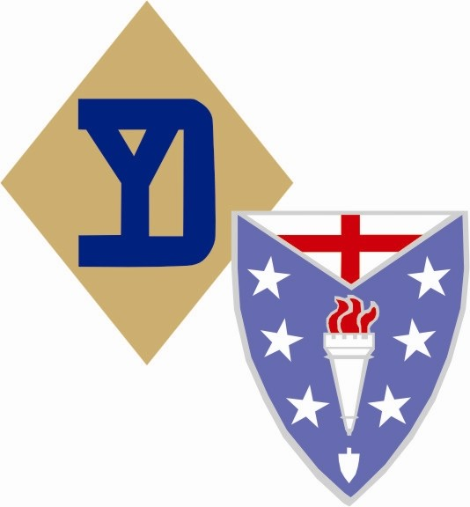

Soldier Guide Book

Guidelines, Requirements and Information
For Soldiers of the 26th Infantry Division

Revision “3” 20130100-HQ1

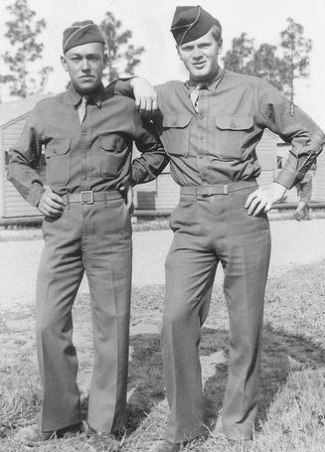

Re-enacting with the 26th Infantry "YANKEE" Division is about the camaraderie of unit cohesion,
commemoration of a great generation and the enjoyment of the WW2 reenacting hobby.
In the Headquarters 26th Infantry “Yankee” Division, Living History Re-enactors, you will get out of it what you put into it.
"Good friends, good times, good memories"

TABLE OF CONTENTS

Topic Page

- Introduction A-1 2
- The Impression A-1 4
- Events A-1 5

- ORGANIZATION AND CONDUCT A-1 6

- Conduct, Tradition, and Attitude A-1 6
- Platoon Organization A-1 7
- Grooming Standards A-1 7
- Rank and Responsibility within the Platoon A-1 7

- CLOTHING AND EQUIPMENT A-1 8

- Uniforms A-1 8
- Equipment A-1 10
- Weapons A-1 10
- Personal and Barracks items A-1 11

- KNOWLEDGE AND TRAINING A-1 13

- Units in the 26th in World War 2 A-1 13
- Drill and Formations A-1 14

- SUMMARY A-1 15
- Appendix I A-1 16
- Uniform Table A-1 19
- Reference A-1 22

INTRODUCTION

Welcome to the 26th Infantry “Yankee” Division WWII Living History / Re-enactment Group. If this is your first time in a reenacting hobby, there is a lot to learn. Especially, if you have never had real world military experience. If you have reenacting experience in another time frame (e.g., Civil War), you already know the basics of reenacting but you will have to unlearn all of the previous time-frame’s tactics and skills and learn WWII.

With the threat of war looming on the horizon in the early 1940’s, the YD was called to active service in early 1941. At the same time congress passed the nation’s first peacetime conscription act, and the YD regiments were brought up to strength with a draft of men from New England. The division spent most of ’41 training at various locations in the American south. In December of 1941, the YD’s year of active service was drawing to an end. The Division returned to Camp Edwards Massachusetts on Saturday, December 6th 1941, and prepared to muster out. The hopes of the men to be out of uniform and home for Christmas ended with the news of the attack on Pearl Harbor the next day.
With the nation now rapidly mobilizing for modern war, the army decided to change the division structure from the old "square" or four regiment organization, to the new "triangular" three regiment division. It was believed that the triangular structure would prove to be more suitable for fast moving, mechanized combat of the type which was demonstrated by the Nazi blitzkrieg. The 181st and 182nd regiments were detached from the division, and replaced with the 328th infantry regiment which had been recently reformed. The 328th had been part of the 82nd Division in WW1, and was famous for being the regiment in which Alvin York had served in during the war. The 181st regiment later went on to be one of the first U.S. Army regiments to see service in the war, fighting on Guadalcanal with the famous Americal Division...
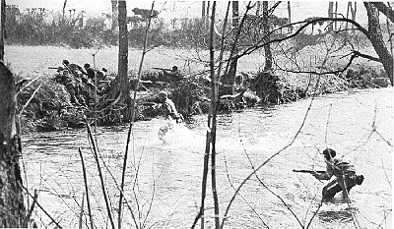
Upon completion of its new reorganization, the YD assumed the task of patrolling the Atlantic coast to prevent the possible landing of Enemy spies or saboteurs. It remained in this role until early 1943, when it began intensive training in preparation for an overseas wartime assignment. That assignment came in August of 1944, when the division boarded transports in Hoboken NJ. Arriving in France several weeks later, the division went into a strategic reserve posture behind the front lines in northern France. In October of 1944, the division, led by Maj. Gen. Willard S. Paul, relieved the 4th Armored Division in the front lines in the Salonnes-Moncourt area. The division participated in the 3rd Army offensive throughout October and November, seizing amongst others Vic-sur-Seille, Marimont, Dieuze, and Sarre Union. In early December the YD was assisting in the capture of the fortified city of Metz.
It was in Metz that the division received news of the German Ardennes offensive. Word soon came down for the division to break off from its current task, turn north and assault into the flank of the German "bulge". During this action the 26th was on the right flank of the 4th Armored Divisions famous drive to relieve Bastogne. Encountering stiff German resistance, the division seized Arsdorf on Christmas day and pushed on to cross the Wiltz River, and to seize the town of Wiltz itself. Following the reduction of the Bulge, the YD took up defensive positions in the ruined city of Saarlauten. Here units of the division found themselves often times in the same buildings as their counterparts in the German army. In March of 1945, the YD resumed its attack, and soon had reached and crossed the Rhine River at Oppenheim on the 26th of that month. With defeat now almost certain, the German army began to fall apart. The YD, along with the tanks of the 11th Armored Division, now pushed rapidly across Germany, seizing numerous towns and hamlets along the way. By the 15th of April the division had reached the 3rd Army restraining line in the vicinity of Hoff. The 26th now turned its attack south, pushing into Austria and assisting in the seizure of Lintz. When the war ended on May 7th, the YD had pushed to the Vlatava River in Czechoslovakia.
The YD was credited with four campaigns during WW2; Northern France, Rhineland, Ardennes-Alsace, and Central Europe. Casualties suffered by the division included 1850 men killed in action and 7886 men wounded. The division returned home in 1946 and again resumed duty with the Massachusetts National Guard.
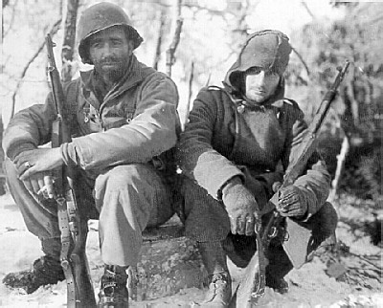
Things remained peaceful for the YD in the post war years. In 1951 the division was about to be called up again for service in the Korean war, but a public outcry arouse in the state of Massachusetts. Many people felt it was unfair to the YD to be the first ones called to duty for three straight wars. The pentagon acknowledged this and instead activated the YD’s cousins in the 43rd Infantry division the final chapter of the YD unfolded in 1993. With the post Gulf-War reduction of the armed forces, the old YD was slated for disbandment. It was a sad day that August when members of the division both past and present gathered at the state house in Boston for a formal deactivation ceremony. In its short existence the YD had fought bravely in both of America’s world wars and served faithfully throughout the peace that followed.
The 26th Maneuver Enhancement Brigade, formerly the 26th Infantry Division is a unit of the United States Army that served in World War I and World War II. It was originally activated as the 5th Division in early 1917, but this became the 26th Division after a few months' service. Prior to becoming a maneuver enhancement brigade, it was a modular infantry brigade combat team.

Authenticity. This is the entire idea behind any living history group. In order to create a "living history" you must take great pains to research and accumulate the items needed to bring to life the time period you are representing.
Our unit goes to great lengths to accurately re-create the experience of the average American foot soldier in the Second World War. From our authentic period camp and the rations we eat in the field, to the clothing and equipment we wear on our backs, we strive to be an exact living recreation of an American rifle platoon during the Second World War.
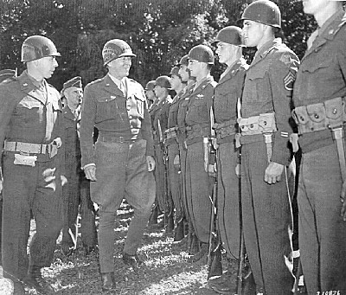
Unlike other re-enactment groups, we focus on the common infantryman, the famous GI, as he appeared in all theaters of WW2. As a member you will see what it was like to fight the German army in damp Belgian forests or the hedgerows of Normandy. You will go face to face with determined Japanese defenders in a simulated Pacific battlefield. The opportunities are endless; no two re-enactment events are the same.
As a living history group, we also participate in living history events and encampments. By doing so, we give the public the opportunity to experience history on a first hand basis. For many veterans who visit us at these functions, we provide a valuable living reminder to the memories of their experiences overseas.
As a member you will start out as a private, a rifleman in a rifle squad. By participating in events you will earn rank and awards. You will have the chance to act as a medic, a machine gunner, a mortarman, or any of the other positions in a WW2 Rifle company. If you have leadership skills, you will see what it was like to command a squad or section under combat conditions.

The “impression”

What is an “impression”? For those new to living history, this is a critical concept. You are not an actual soldier of any war, so you will be doing your best to recreate the soldier of that war. The impression is not just a uniform. It includes knowledge, skills, and attitude. Your knowledge of the time and the soldier’s place in it must be deep and accurate, your performance must honor the soldier and educate the public, and your attitudes – as an individual and as a part of the team – do a great deal to determine the fidelity and value of your total impression.

Our impression is of the 26th Infantry “YANKEE” Division, Following the 1944 TO&E. The 26th Division met its baptism of fire as a Division in France during the Battle of Moncourt wood (22 October 1944). We have built a program around the preparations the 26th Infantry “Yankee” Division went through to prepare for deployment to the ETO, so in order to participate in this activity; you need to have the equipment they had at that time. The uniforms and equipment they had then were pretty much standard up to that point – every soldier had basically the same kit and it is how they went into combat. In addition, these items would be used from then till the end of the war. After Moncourt Woods, through the campaign through Northern France, they had many replacements coming in with all the new equipment. In addition, in late summer, the Army changed/modified its uniforms and equipment and it can be confusing trying to figure out just when something became available and whether you can use it or not; the result is people trying to make up stories about why they have this item or are wearing that uniform. Authenticity and uniformity is what we are after; a uniform is called a uniform for a reason. So, if the standard was “anything WWII”, then you would run the gamut of clothing and equipment. We have included an appendix on uniform standards and procedures – it is worth a careful read.

By picking a specific timeframe it actually makes it a bit easier because you can focus and know what equipment and uniform items to look for when you are shopping. This way you won’t have to worry about trying to determine when some of the later gear was adopted and issued or waste you money on things you don’t need or can’t use.
(We’ve all wasted money!)

Does that mean you shouldn’t buy some of the later gear? No, especially if it is a good price. You will find this hobby a bit addictive and once you start, you’ll want to get at least one of everything. And there may be times when we may want to show the later uniforms and equipment. But our focus is both early and late war. Note: The Majority of the YD was issued M1943 Uniforms for Deployment to the ETO.

The uniforms and equipment needed for this impression should be that which was authorized and available up to and including that date. As such, certain items are not used with this unit. Mainly, anything dated 1945 is frowned upon, check with the unit authenticity officer to be sure. The important thing to note is that the equipment and uniforms from the earlier part of the war can be used for the entire war period, whereas the later dated items can only be used for late war events. Always pay attention to the period of the war that the event will be. This means that you do not have to buy double of everything to cover the entire war period.

These guidelines are not "hard nosed", they are GUID LINES. Everything is done within reason of the time period projected. The Living Historians that have been here researching this information for years are you best bet for accuracy. Do not be intimidated by them. But be warned up front, this can get a bit expensive. Your basic kit can cost you $500 or more, plus the cost of a weapon ($600-$1000). Whether you are new to living history or coming to us from other periods and/or units we will make every effort to assist you. Not only with consultation, advice and training, but also with the loan of equipment to get you started, as well as guidance in purchasing equipment. It is our hope that these guidelines, along with dedication and training, will assist you as a member of the YANKEE DIVISION in presenting the most accurate portrayal of the American soldier during World War II possible.

Events

We participate in many “Living History and /or Re-enactment” events throughout the year. There are basically three different types of events: Field/tactical, Living History/Display, and Ceremonial/Parade.

Field/Tactical

For these events, we sleep either in the field (in tents) or in barracks and then participate in battles against the German re-enactors. Everything we use is either original or unit approved reproduction items. Modern camping gear and such is not authorized. Usually there are no public or spectators involved in this type of event. We participate because it is enjoyable and challenging, and because our experiences contribute to a deeper knowledge of the soldiers’ lives and challenges and because the improved knowledge and skills contribute to a quality “product” for public education.

Living History/Static Displays

For these events, we do demonstrations to the public on the life of the WWII US soldier. These can range from table top displays of items to a full encampment with field demonstrations. Some are geared towards the 26th Infantry Division specifically, such as displays we’ve set up for the Living History Association, and some are more generic, such as tactical demonstrations as sometimes done at field events.

In some cases, the field and living history type of events are combined. We may have some private battle time with no public and then do a demonstration for the pubic.

Ceremonies/Parades

These events are parades, honor guards or color guards for various events.
You can choose which events or types of events you would like to participate in. Minimum participation to maintain membership in this group is one event per year. For all of these events, the proscribed uniforms will be identified ahead of time. To fully participate in any event, you will need to obtain the required uniforms and items needed for these events.

Organization and Conduct

Conduct, tradition, and attitude

Before we move into a listing of the uniforms and equipment needed, the point of whom and what we are representing and how you represent them needs to be understood. During its active service in World War II the 26th Infantry Division established many traditions. Traditions of, devotion to duty, self sacrifice versatility, dependability, and loyalty to both unit and country. A pride in one's self and unit became instilled in every soldier. Gaining an understanding of this hard earned, but well deserved pride is paramount to be able to represent these soldiers of our past. When we as members of this unit present ourselves in front of the public this pride and confidence must manifest itself in each members conduct, bearing, and attitude. Without it you can not adequately and truly represent these soldiers. Remember, preserving these traditions, and the memory of the men who made them, is what we are all about.

The historical military impression is not only a question of having the right clothing and equipment, but of proper attitude and conduct. The clothes and equipment don't make the soldier, how you wear them and conduct yourself does. You are representing a soldier, so be prepared to act like one! You should be well versed in the period military customs and courtesies, and use them. You should be familiar with your equipment, how to pack it, wear it, and display it. You should be aware of the types of uniforms and the proper method of wearing them, and not look like a "civilian in surplus clothing." You should be familiar with your weapon, its nomenclature, and how to field strip it. You should know and be able to perform the basics of close order drill and the manual of arms for the period. In short, you need to become familiar with all the basic skills that a soldier of the period would know and be able to apply them. To do any less is a disservice to the public we are trying to educate and the veteran we are representing.

The soldiers we portray were drilled every day and did not have to study hard to be a soldier. Skills were learned through constant and repetitive training and through experience. We do not have this luxury. It is the responsibility of each member of the platoon to study and practice on his own. We will teach, and every effort will be made to get together to train, but each member must take the initiative to do his own research, and put forth the effort and desire to learn and become skilled in his job as a soldier. The most important thing to remember, especially if you don't have prior military service or experience as a historical interpreter, is to listen, learn, and practice. You will be depicting yourself as a U.S. soldier of the 26th Infantry Division during World War II, and not just wearing a 'costume'. You also have to act accordingly. As much as this may be a hobby, to do it right means to be a soldier. Our unit operates as a military unit during WWII.

To borrow a concept from today’s Army, we have three goals: BE, KNOW, and DO.

BE: Technically and tactically proficient. Commit to character, commitment, competence, and conduct that honor the 26th Infantry “YANKEE” Division veterans of WWII – and today.
KNOW: Unit history, soldier skills; your weapon and equipment; the details of your impression.
DO: Set the example for others; respect the rules and standards of the Headquarters 26th Yankee Division Living History Re-enactors ; help build the team.

Organization

The basic unit in a WWII Infantry Division is the 12-man rifle squad. That is how we will be organized when doing any event other than a display. The more people we have, the more squads we will have. When we get to three squads, we will activate the platoon organization. The platoon's organization is based on the U.S. Army Table's of Organization and Equipment (TO&E 1944). It consists of a headquarters section and three to four rifle squads:

Platoon Headquarters Section

1 - Platoon Commander (1st or 2nd Lieutenant)
1 - Platoon Sergeant (Technical Sergeant)
1 - Platoon Guide (Staff Sergeant)
1 - Orderly/Runner (PFC, Pvt.)

Rifle Squads (3)
1 - Squad leader (Staff Sergeant)
1 - Asst. Squad leader (Sergeant)
1 - Automatic Rifleman (BAR) (PFC)
8 - Rifleman (PFC/Pvt.)
1 Asst. Automatic Rifleman (PVT)

On occasion (as at larger tacticals) we will go with smaller squads, in the 7-9 man range. This is a reflection of practicality, but also of realism. From 0700 on 6 June 1944 until replacements began arriving, most rifle companies in combat had to operate despite many casualties; hence, smaller squads are not a compromise of accuracy.

GROOMING STANDARDS

Another important aspect of the impression is how you wear your hair. Your hair will be close cropped and off the ears, sideburns short, and tapered up the back. Look at the period photographs, your haircut should look proper and stylish for the '40s, not today’s look. For example, the “high and tight” haircut worn by servicemen today was not seen in the 1940’s; hair tended to be longer on top than in today’s military units. One of the requirements of the Commanding Officer was that you shaved every day! Absolutely no beards! If you are one of those guys that has to have a mustache because you’ve had it since you were 6 years old, you need to either trim it to a very thin style (both in thickness and width) as was the style in WWII (again, look at pictures – think “Clark Gable”) or shave it off. Nothing ruins a WWII impression faster than a big bushy modern mustache. And don’t worry, it will grow back!

In particular, we do not permit the disheveled “Kelly’s Heroes” look. This sometimes appears in photographs, but only those of men who have been in sustained combat for long periods without relief. It is certainly not representative of our impression.

RANK

We pride ourselves on following the 1944 TO&E and our training program. We don’t want to become one of those units that has a Colonel, a major, four top sergeants, six technical sergeants and 2 Privates (don’t laugh, they are out there). There are only limited slots within the platoon TO&E for NCOs. No one coming into the YD HRG should wear any rank unless appointed by their Company Commander. Remember that we are representing rifle squads of line infantrymen as they were in WW2. In 1943 the US Army decided that a Staff Sergeant would lead Infantry squads and the assistant squad leader would be a Sergeant rather than a Corporal. They were in charge of a squad of 12 men.

The NCO positions are positions of responsibility, just as they were and are in the active Army. Each squad and section leader has a responsibility to those they are leading, to look after their men's needs, comfort and welfare before their own. The YD's NCOs must know their jobs, both as re-enactors and leaders. Above all they must be able to lead and to teach and, above all, to set the example.

Clothing and Equipment

In the reenacting hobby, you’ll hear the word “authenticity” used in just about every other sentence. What this means is that everything your wear or use or do in this hobby should be authentic to the time period. For WWII, there are still plenty of original items available and in the past 10 years, quality reproductions have become available. There is a lot to learn about uniforms and equipment of WWII. Just because something is Army issue, is green and has US stamped on it, doesn’t mean it is appropriate for this impression. Don’t run down to your local surplus store and expect to find WWII stuff just lying around. Just because it is an M-1 Helmet, doesn’t mean it is a WWII M-1 helmet (yes, there is a difference). So before you go rushing off to buy everything, wait and have one of us assist you so you won’t spend a lot of money on things you can’t use (we will assign a sponsor to help you in this difficult buy very enjoyable project). It will actually cost you less to do it right the first time than to try and get by with something that is not correct and you can’t use.

Authenticity means having the correct uniforms and gear, not “close enough”. All uniforms, equipment, and weapons will be appropriate to the Yankee Division during their service in World War 2. Any modifications of the standard uniform and equipment will be made accordingly for each specific event and time frame being portrayed. The impression we are trying to put forward is that of the average line Infantryman, we are not an elite special unit.

The following listed uniforms and equipment are the essentials required for the basic impression. This may seem like a lot of equipment and uniforms, and it is. But it is the basic kit of what the soldier would have had issued to him. If you are new to this hobby, do you need to go out and buy everything for your first event? No, however, you need to have the basic field items, which would be the OD M1937 wool uniform, boots, leggings, M41 jacket, web gear, rifle, and helmet. (Items marked with an *.) You can acquire the other things as you find them. The good thing about Army items is that they were all dated. When buying WWII items, you need to buy things that are dated before 1945. Some items that are dated later can be used but you have to know what they are. Research is the key to this hobby. We have a lot of experienced people in this group that are more than willing to help out.

UNIFORMS

As a rule, we wear the olive drab (OD) M1937 wool uniforms. You should eventually get two sets of the OD wools; one for the field and one for dress. The HBT (cotton herringbone twill) fatigue uniform is only worn on certain work details. With the selection of reproduction uniforms available, not to mention original uniforms, it should be no problem putting together a complete kit of US Uniforms. Although originals are available, if you are a large person (42 chest, 38 waist or above) you will probably only find reproductions in your size. All jackets and shirts will have the 26th Div. patch on the left sleeve. The patch should be approximately 1/2 inch from the shoulder seam vertically oriented on the sleeve.

OTY ITEM

1* Belt, trouser, khaki web w/ open frame buckle
1* Cap, Overseas, OD wool w/ infantry blue piping.
1 Coat, service, OD wool, w/ all appropriate insignia including regimental DIs
1* Field scarf (necktie), khaki or Black for early war 1937-42
1* Jacket, Field, M-1941 pattern (repros available)
1pr*. Leggings, M-1936 Army pattern
2 pr.* Service shoes / boots (one pr. for field use, the second for barrack/dress wear)
2* Shirt M1937 or 41 special, OD wool, enlisted pattern (repros available)
6 pr. Socks, OD cotton and/or wool,
2* Trousers M1937, OD wool serge, (repros available)
2* Undershirts, tank or "T" type, OD or white cotton
1 (set) Enlisted Brass for service coat (one “US” Disc and one Infantry Disc)

Decorations and awards
Only the unit can authorize your awards

American Defense Service Medal Ribbon: For successful attendance of 3+ Living History displays in one re-enacting year.

Women's Army Corps Service Medal Ribbon: For female member attendance of 7+ events (awarded after 1 year of unit participation).

American Campaign Medal: For unit member attendance of 7+ training events (awarded after 2 year’s of unit participation).

Asiatic-Pacific Campaign Medal Ribbon: For unit member participation in 3+ Pacific Theater Tactical’s.

European - African - Middle Eastern Campaign Medal Ribbon: For unit member participation of Ft. Indiantown Gap and / or Reading PA event with the unit. Or at least 7 ETO Tactical events. (Maximum of 4 battle stars, for each aforementioned GAP/Reading event listed).

World War II Victory Medal ribbon: For completion of 3 years of active member service in the 26YDHRG.

Army of Occupation Medal ribbon: For successful completion of 4+ years of active membership. Must be awarded by the unit Commander only.

WW1 Victory medal Ribbon: For successful completion of 5+ years Active service in the 26YDHRG & above age 45. Must be awarded by the Unit Commander only.

WW1 Occupation Medal Ribbon: For Successful completion of 5+ year’s active membership with at least 1 in a leadership position and above the age of 45. Must be awarded by the Unit Commander Only.

Mexican Service Medal Ribbon: For 10+ years of service, age over 45, prior military service & held a leadership position.

Mexican Border Campaign Medal: Awarded to members of the 26YDHRG over the age of 45 for 15+ years membership. Note: Member must not have held a leadership position. Authorized and awarded by the Unit Commander only.
Marksmanship badges: Are worn if you earned them through the unit.

We have live fire practice at a firing range at least 2-3 times a year.
Scores are posted following.
You are required to come to at least 1 and shoot for score to earn these badges.

Service stripes: (worn on the left sleeve) 1 stripe indicates completion of three years in the Army (1 Service Stripe = Three Years of Service in the 26YD HRG).

Overseas Bars: also worn on the left sleeve above service stripes) indicates 6 months of overseas service. (1 Overseas Stripe counts for 7 ETO Tactical Events with a Maximum allowance of 6 Stripes per Re-enactor.)

All other ribbons or awards will be authorized on a case-by-case basis, per the 26YDHRG unit commander. However, certain personal achievement awards, such as the Silver Star, Bronze Star, Purple Heart, CIB, etc., will “only be worn if you have personally earned this award in military service”.

Members who have served or are serving and have decorations should wear only those appropriate for the impression at a given event.
For example: most modern soldiers will have earned the Good Conduct Medal; if so, it is appropriate for your impression.

This is a touchy subject in the reenacting world. Some people like to get every ribbon, qualification badge and other shiny object and put them on their uniforms. Others feel that since you were not in WWII and didn’t earn anything, you shouldn’t wear anything. We kind of split the difference on this these two extremes. Since we are trying to accurately and historically represent the normal, average WWII soldier of the Yankee Division, we allow certain ribbons or awards to be worn provided you qualify for that ribbon by event participation. And only what a basic infantryman would have had.

There will be times when we wear the dress or "class A" uniform. And people always ask (or don’t) what ribbons or other insignia they should/could wear. Since we are depicting the Yankee Division, You should not wear any combat ribbons on your Class A uniform coat. The only generally authorized ribbon to be worn is the European, African, Middle Eastern (EAME) Campaign Ribbon (or ETO Ribbon) with no battle stars. If your persona is of a National Guardsman or draftee who was activated / drafted in 1941, then you would be eligible to wear the American Defense Ribbon. Again, only if authorized by your unit commander.

Distinctive UNIT insignia

The 26th HQ DUI is worn on the uniform of members who are part of Division Headquarters. For the other 26YD re-enactment units, members wear the respective DUI for that unit. All new members must complete one year with B Company. NOTE: Not all soldiers had DIs during WWII.

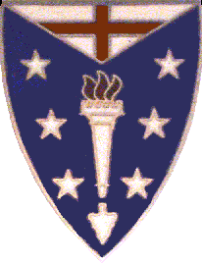

Distinctive Unit Insignia for the 104th Infantry Regiment

Equipment

All canvas web gear and other equipment would be best if dated 1944 or before. Your helmet should be the WWII M-1 pattern with sewn-on khaki web chinstrap, either with fixed chinstrap bales (preferred) or swivel bales. Helmets made post-1950, and/or with clip on chinstraps lack accuracy. NCOs should mark the back of their helmet with a white horizontal bar approximately 4 inches long by 1 inch tall. Officers should mark the back or their helmet with a white vertical stripe approximately 1 inch wide by 4 inches tall.

QTY ITEM
1* Canteen cup and cover, 1910 pattern
1* Cartridge belt, dismounted pattern 10 pocket
1* Entrenching tool, M-1910 pattern "T" handle, w/cover or 1943 folding entrenching tool or pick with handle
1* First aid pouch, with field dressing
1 Gas mask w / MI VA I carrying (kidney) bag, khaki canvas
1* Haversack (pack), w/ meat can pouch, 1928 pattern
1* Helmet, M1, w/liner
1* Mess kit (meat can) w/ knife, fork, and spoon
1 Rifle cleaning kit, complete, for M1 rifle
1 Shelter half, khaki or OD canvas w/buttons
5 Tent pegs, wood
1 Tent pole, folding
1 Tent rope
1-2* Bandoleers, ammunition, khaki, unmarked
Weapons

The U. S. Rifle, Cal.30, M1 semi-automatic rifle or Garand rifle, was the standard arm carried by an infantryman during WWII. The 1903 Springfield rifle may be used if that is all you have available but the M1 is preferred. Specialized weapons such as the M1 carbine, or 1911A 1 automatic pistol will not be used unless authorized by the Company Commander. One Browning Automatic Rifle (BAR) is authorized for each rifle squad.

QTY ITEM
1* Rifle, M-1 semiautomatic (Garand) w/ M-1907 leather or M-1 web sling
1* Bayonet, M- 1905 16 inch, w/ scabbard
Or Bayonet, M-1942 8 inch, with scabbard
1 Browning Automatic Rifle (BAR)

Mortars and M1919A4 Machine Guns where used by the Heavy Weapons Platoon as you will see in various training, static displays and other events.

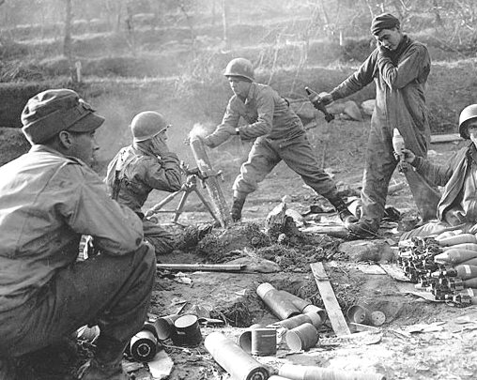

Personal effects and barracks items

From the beginning, the 26th ID has been a leader in living history impressions. We are known for a quality barracks impression, which is why we recommend and encourage you to obtain a full kit. Many of the programs that we do involve the life of the soldier in the barracks as well as the field. The following listed items are required for a barracks impression. These items will enhance your impression and will help increase your personal comfort as well. Many of the personal hygiene disposable items such as toothpaste and shaving soap can be period commercial (civilian) items.

QTY ITEM
- Blanket, M-1934 OD wool
1 Bag, clothing (Duffel), green canvas, or Bags, duffel (2: A & B), blue denim
1 Bag, laundry, khaki, OD, or Denim
1 Foot locker, period pattern w/tray
4 Handkerchief, OD cotton
1 set Identification tags, WWII army pattern
1 Manual, FM 21-100, the Soldiers Handbook
1 Pillow w/ cover
1 Sewing kit,
2 Period hygiene kit, to include:
Safety razor, mirror, shaving soap, razor blades
Foot powder, comb,
1 set Sheets, white, single bed (2), Pillow case, white (1)
1 Shoe brush, and brown polish
1 Towels, set, plain, white cotton, bath, hand, wash clothe
1 Tooth brush, and tooth paste or powder

Additional uniform items

QTY ITEM
1 Cap, Knit wool
1 Cap, overseas, khaki cotton w/blue piping
1 Cap, fatigue OD herringbone twill (Daisy Mae style)
1 Gloves, OD knit wool or suitable period substitute
1 Jacket (sweater), knit wool 1943 pattern
1 Overcoat, OD wool, M-1926 pattern
1 Raincoat, rubberized or synthetic resin coated, issue pattern
1 Scarf, OD knit wool
1 Shirt, herringbone twill, army pattern (repros available)
1 Shirt, long sleeve khaki cotton, and appropriate insignia
1 Trousers, khaki cotton (repros available)
1 Trousers, herringbone twill, army pattern (repros available)
3 pr. Under drawers, button front, OD or white cotton (repros available)
1 Netting, helmet

Remember, you don’t have to run out and buy it all at once, Take your time and get a good price.
(Diligent shoppers make the best collectors)

Small Things

Sometimes it’s the small things that can make or break an impression. Sometimes its things so simple we forget about them.

Watches – Should be regular dial faced watch with 1940’s style watch bands (you can research these in 1940’s magazines). Plain simple Timex’s works.

Glasses – If you wear glasses, consider wearing contacts for the day (if you don’t already). If you can’t wear contacts, you need to get a set of frames that are similar to Army issue or Civilian purchase. You can buy old frames and get your prescription put in. Again, research the pictures of the time period. There are some optometrists that specialized in re-enactor eyeglasses. Modern frames won’t work.

Knowledge and Training

As you begin your quest to be a WWII soldier in the Yankee Division, there are a lot of things you will need to research and learn. Don’t be afraid to ask questions. To get you started, there are two books you should obtain and read. The first is the War Department Basic Field Manual 21-100 (FM 21-100) dated 1941 this is a required manual. This is the basic manual for the soldier. This gives you the instruction on how to do just about everything you need to know as a soldier. The second book “Normandy to the Bulge” - Richard D. Courtney, Southern Illinois University Press, 1997. An excellent first person account of a GI, Many great tidbits of information on the everyday life of a soldier in WW2.

You also need to know the life of a soldier during that time frame. If you have current-day, real life army or military experience, you have the knowledge of the military culture and how things kind of work. However, in order to portray a WWII soldier, just like those coming from other re-enacting time periods, you will also have to unlearn certain things, some terminology, some tactics, and such and learn the WWII way.

In other words, this hobby requires a lot of research. You are not going to learn all of this overnight. It will take some time. We have people who have been doing this for more than 22 years and they are still learning things.

Training opportunities

At most events, members of the YD will prepare special training programs to improve performance and impression. 4 Training days are set aside every year so there is no excuse for not knowing. Never miss an opportunity to learn!

Units in the 26th in World War 2

101st Infantry Regiment
104th Infantry Regiment
328th Infantry Regiment
101st Combat Engineers
101st Field Artillery
102ndField Artillery
180th Field Artillery
263rd Field Artillery
114th Medical Battalion
26th MP Platoon
39th Signal Company
726th Ordnance Light Maintenance Company
26th Cavalry Recon Troop
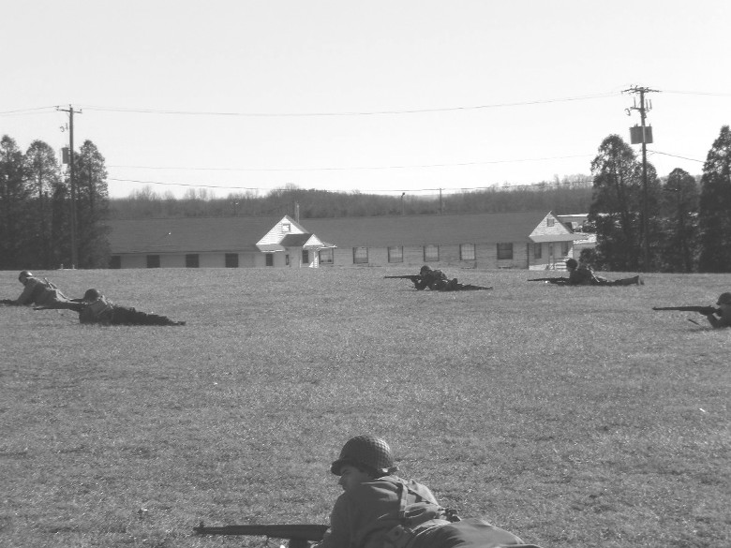

Drill and formations

Mastering the basics of close order drill and the manual of arms is integral to developing discipline and precision. A well-drilled unit generates an image of discipline and proficiency, and a pride in them selves, to anyone that sees them. The first thing that any soldier learns, regardless of branch of service, nationality, or period in history, is the fundamentals of drill. It is the foundation upon which all the aspects of being a soldier are built.

As stated in a manual on Military Discipline, Courtesies, and Customs of the Service, dated 1943, "Among the drills and exercises that comprise 'disciplinary training', the most important are physical drill, close order drill, and the ceremonies. Such exercises should be executed with accuracy, precision and promptness. A great many look upon this work as drudgery and a waste of time. In truth there is no greater aid to obtaining a high standard of discipline in an organization than the drill and ceremonies mentioned above."

Close Order Drill, and the Manual of arms

We do go into detail on drill for the individual, squad, and platoon. There is enough material on the subject to fill a book, and in fact has filled several. (The Soldier's Handbook, FM 21-100, 1941, or Infantry Drill Regulations, FM 22-5, 1941 are two primary source books.) We point out the fact that each member within the YD must take the responsibility to learn the basics of individual of Drill. The more proficient each man can become in performing the individual movements, the easier it will be for him to mesh with the unit when the Company, Platoon or Squad is functioning together. If you need help in mastering some of these skills, all of the NCOs in the unit are willing to help. Remember, the soldiers we portray learned through daily repetitive training. We don't have that luxury. Training and practice doesn't begin and end at each event or program. Each man on his own between events must carry it on.

Listed below are some of the first basic movements without arms that each man should strive to gain proficiency in:

Position of Attention
At Ease
Parade Rest
Stationary Facings – Left face, Right face, About face.
Hand Salute.
Marching Facings; Left Flank, Right Flank, the Obliques, To the Rear March, and column movements.

Drill with the rifle, referred to as the Manual of Arms, is the next level that each individual soldier must accomplish. Gaining proficiency and "snap and pop" in performing these movements, both as an individual and when functioning as part of the platoon, will ultimately develop pride, confidence, and trust in both yourself and your fellow soldiers. Nothing looks sharper than a platoon performing the "Marching Manual", with every hand and every weapon moving as one. But, to get there, each man must first learn and become proficient in the basics. Some of the first basic rifle movements that you should learn are:

Order Arms (to include the position of attention, and moving to the order from any position)
Trail Arms
Port Arms (to include being able to move to port from any other position)
Present Arms
Right Shoulder, and Left Shoulder Arms
Secure Arms
Parade Rest
Rifle Salutes.

There are many more things that you will have to learn as a member of a squad and platoon, but if you master the basics listed above, learning the rest, and blending as part of the unit will come easily.

SUMMARY

Our unit maintains a high level of pride in themselves and the Yankee Division, knowing that we present the most accurate and professional impression possible. Our goal is to preserve the proud heritage and traditions of the 26th Infantry “Yankee” Division and the US GI soldier during World War 2. We also strive to educate the general public about the many sacrifices that have been made by these G.I's. Sacrifices that helped earn and preserve the freedom and privileges we now enjoy and in some cases take for granted.

You may also be somewhat intimidated by what appears to be a rather substantial investment. Not all of the equipment listed needs to be purchased immediately before you may participate.

If you are new to the WWII re-enacting hobby, we recommend that you don't run out and buy, site unseen, without consulting with one of the platoon's senior members. Ask your NCOs! One of the biggest mistakes that a new member can make (and we have all made them) is to buy something that they know very little about. What looks like a bargain could wind up costing money for an incorrect piece of equipment. Now that you have a better insight into the impression, we hope that you are ready to continue on. Come join us in preserving the memory and traditions of the 26th Infantry Division and the United States Infantryman in World War 2.
Appendix I: Wearing the uniform

Uniform SOP

The following specifications prescribe the uniform to be worn for each type of activity commonly scheduled for the Yankee Division. We expect each member to make every effort to meet these standards.

- Garrison, duty (Class B). This is the uniform worn in garrison (e.g., at Indiantown Gap while in the cantonment area); for roll call formations, in the mess hall, etc. This is the “default” uniform.
Wool shirt and trousers, tie, garrison cap, service shoes, belt. This is the “Class B” uniform, and represents what soldiers wore when not assigned to special duty (fatigue, guard, drill).
Shirt and trousers should be clean and pressed, tie worn whenever on duty in garrison. When not on duty or at “rest” (e.g., hanging around the barracks but on call), tie may be removed. Shoes should be polished – buffed and brushed or spit-shined. In Class B, soldiers wear the service shoe, not the roughout or buckle boot.
Note that soldiers were careful about wrinkling their Class A-C uniforms. If they were hanging around and not on duty, they often wore skivvies to preserve their good uniforms (particularly since lack of a clean set might (would) risk denial of a pass.
When weather is cold, the M41 jacket is worn; when very cold, the wool overcoat. NOTE: There will obviously be exceptions (while the 41 is preferred, the M43 field jacket may be substituted; not all have the overcoat). An effort should be made to have all soldiers dressed alike in formation.
NOTE: The knit wool “jeep cap” is an abomination in the eyes of the Lord God and to every real soldier. It should be worn ONLY as padding under the helmet in the field in cold weather. It is NOT a Class B cap. It may be used for night patrols when in wool field uniform.
- Garrison, drill (Class B). This is the uniform worn for close order drill. There are many ways of doing this, but most pictures and records suggest the following:
Class B (as 1 above), with garrison cap, cartridge belt without suspenders with first aid pouch and bayonet attached. Bayonet hangs from the left rear hip. Unless the drill field is muddy, leggings are not generally worn. If weather is cold, the M41 jacket may be prescribed; if very cold, the wool overcoat with cartridge belt on the outside.
- Garrison, drill (Class A). This is a special case, generally reserved for formal ceremonies. Uniform is as for Class B drill, above, except that the service coat is worn. The service cap or garrison cap is acceptable, with the stipulation that all soldiers in the formation wear the same headgear.
- Garrison, Class A: As (1) above, but with the service coat. Garrison cap or service cap may be worn, but in formation all should be alike to the extent possible. For social occasions, either cap is acceptable. Garrison belt is optional. Footwear is either garrison shoe or low-quarters, polished. Brass on service coat should be polished.
- Field uniform: Class B with appropriate load carrying equipment. For most soldiers, the M1928 pack is appropriate. In the field, 2-buckle boots are acceptable, but roughouts or service shoes and leggings are preferred. In cold and wet weather, shoepacks or rubber galoshes are acceptable. Jump boots are discouraged, on the grounds that an actual airborne infantryman might remove them from your feet after killing you. M1 helmet is worn under most circumstances; on night patrols, soft caps (this is one acceptable use for the knitted jeep cap; helmets are not worn on night patrol because of noise) or no headgear are worn. At the commander’s discretion, haversacks may be dropped and stored in the rear, soldiers wearing only cartridge belt and bayonet.

- Summer khaki (Class C): This is the summer or tropical equivalent of Class B, a garrison uniform. The khaki uniform may be worn with or without leggings for drill, but when worn for social occasions, meals, etc., it is worn with garrison shoes and without leggings. The tie is always worn with the khaki uniform unless otherwise specified; the footwear is polished garrison shoes or low-quarter shoes.
Members may wear the overseas cap or the service cap, but only the khaki versions. In formation, all will wear the same headgear.
- Fatigue uniform (Class D): Worn only for work details as specified in the daily schedule (e.g., loading, KP). HBT trousers and coat with HBT cap (“Daisy Mae” style preferred because the mechanic’s hat was a later addition). Pre-1942 blue denim fatigues are acceptable but not preferred.
Additional notes:

It is easy to improve appearance simply by understanding how soldiers dressed in the 1940’s. They were not making individual fashion statements or trying for a “Kelly’s Heroes” look; if they did, they would enjoy the stockade or at least a little NCO justice. DO NOT PORTRAY A MOVIE; portray the real soldiers of WWII.

- Avoid mixing uniforms. For example, Class B is worn with the overseas cap, not the HBT headgear or the wool “jeep cap”.
- Avoid poorly fitting uniforms. Trousers should fit comfortably around the waist, not pinching and not hanging open. Cuffs of sleeve and trousers should be the correct length.
- Correct wear of the cap or hat. No uniform hat is made to be worn on the back of the head. The service cap, wool or khaki, is worn square on the head with the visor two fingers above the ridge of the nose. The overseas cap is worn tilted slightly over the right eye, square on the head and not “mashed down”.
- Exceptions to the standing uniform are made consistent with weather conditions and other special circumstances; however, the decision is for the commander, not the individual.
- Shoes should be properly polished unless they are dubbed roughouts. Roughouts or buckle boots are not to be worn with Class A or Class B – they are “field only.”
Smooth out shoes (service shoes type I and low-quarters) can be brushed and buffed or water-shined, but should in either case appear clean and lustrous. Note: For inspection or pass, it was customary for shoes to be water (“spit”) shined. A spare toothbrush should be used to apply polish along the sole edges and over the upper sole stitching (without waterproofing, the stitching will rot).
NOTE: Do not use the same applicator brush for polish and dubbing. The results will be disappointing and the brush will be useless afterwards for either task.
- Brass should be polished. This includes removal of lacquer preservative. Most brass items are issued with a coat of lacquer that must be removed by brisk polishing.
- Dangling belt tabs. The belt with hollow buckle (“beer bottle opener”) and keeper, black anodized, should be adjusted to the soldier’s waist so that the black tip is just exposed beyond the buckle – not hanging out 4-5 inches.
- The placquet shirt front of the wool shirt or khaki shirt should be aligned with the edge of the fly so that there is a straight line from collar to crotch, and the left edge of the belt buckle also aligned. This is called the “gig line”. Yeah, obsessional; but it’s “Army”.
- When worn as a fatigue uniform, the HBT trousers are not generally worn with leggings; when worn for drill or as a combat uniform, leggings are commonly worn.
- Hats are not worn inside unless the soldier is on guard duty, in which case they are always worn. Hats are not placed on the dining table or the bar.
- When the overcoat is worn, so are gloves.
- An important issue is that of buttons. All pockets and cuff closures are buttoned at all times (and sleeves are not rolled on the Class B or Class C garrison uniform). Most soldiers simply stitched the pocket flaps of their service coats shut, since the appearance was neater and they would not be tempted to put stuff in the pockets. (Why, you ask, have pockets on the uniform if they are not to be used? Answer – to tempt soldiers to put things in the pockets so NCOs can make their quotas of corrections and pass rejections.)
Obviously there would be exceptions. Under combat conditions, sleeves might well be rolled up. When wearing the Class D (fatigue) uniform, there are many conditions under which sleeves would be rolled as well (e.g., peeling potatoes; washing pots and pans on KP). Khakis worn in the tropics as a combat uniform might be subject to relaxed standards (no ties, for example, or rolled sleeves), though the Yankee Division did not serve in the tropics so the matter is moot. The question here is whether such informalities were permitted as a rule; in fact, they were not.

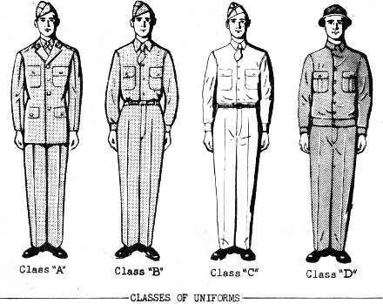

Uniform classes. Note that the tie is worn for Class A-C. This is almost always the case in garrison (and in combat in some cases – General Patton imposed fines in 3rd Army zone for failure to wear them, even under fire!). These soldiers also have straight “gig lines” and caps are correctly tilted.

Uniform Table

Class | Uniform | Headgear | Tie (Y/N) | Boots | Inclement Weather
A | Wool shirt and trousers, service coat | Garrison or service cap* | Y | Field shoes, smooth out or low-quarter | Overcoat or raincoat
A (drill) | Class A with cartridge belt, bayonet hung left rear. | As for Class A | Y | Leggings may be specified | Overcoat or raincoat
B | Wool shirt and trousers | Garrison cap | Y | Field shoes, smooth out or low-quarter | Field jacket, overcoat, or raincoat*
B (drill) | Class B with cartridge belt, bayonet on left rear of belt |  | Y | Field shoes, leggings or 2 Buckle for Late War | Field jacket
B (field) | Class B with cartridge belt, canteen, first aid pouch, M1928 haversack, bayonet | Garrison cap, M1 helmet | Y* | Service shoes or, rough outs, with leggings, preferred; buckle boots acceptable for Late War | Field jacket, overcoat, raincoat; sweater may be worn, but not as outer garment*
C | Khaki shirt and trousers | Garrison cap (khaki) or service cap (khaki)* | Y* | Service shoes, smooth out or low quarters | Raincoat
D | HBT (preferred) or blue denim | Fatigue hat (“Daisy Mae” preferred)*** | N** | Field shoes, rough out | Raincoat

* All should wear the same in any formation.

** As specified by the commander. For example, if drill is in muddy conditions, roughouts may be substituted.

*** In the prewar Army, soldiers typically acquired a second campaign hat.

How to “spit shine” shoes or boots

Unless you are a law enforcement officer or have military experience, the art of spit-shining (really, “water shining”) is largely forgotten. Since the soldiers we honor did it, we should learn it as well. It is also a zen-like experience that allows for long periods of meditation and a general character-building experience.
This shine would be applied for inspection (in garrison, usually on Saturday) or for pass, when soldiers would be inspected again to verify that they were presentable to the public before being released from the company area. After that, they were the problem of the provost marshal. If they passed out in the gutter of the nearest town or got caught in a cathouse raid, at least their shoes would be impeccably shined.

You will need:

- Smooth-out shoes or boots (service shoes or low-quarters); don’t bother trying to spit-shine roughout footgear.
- Tin of brown or russet wax polish (brown kiwi will do well enough).
- Soft rag; old cotton t-shirt material will do very well.
- Toothbrush; this should not be the brush you use to clean your weapon or – important health tip – your teeth.

Preparation:

Remove all dust and mud from shoes; they should be as clean as you can make them. Use the toothbrush to clean the inside of the soles (where they join the uppers). After brushing, wash the bristles to remove grains of mud or dirt.
Remove the top of the polish can; fill the top with tap water and place it in a handy location next to the part with the polish.
Take a deep breath, and repeat three times: “This is worth it.”

Applying a base:

The first step is to apply what is called “the base”. This is the hardest part, and beginners usually quit in disgust before they have finished the job. What you will be doing is applying very thin layer after layer of polish, using water to extract the oil and leave the wax, until the pores of the leather are filled and a layer of wax polish is in place.
Wrap the shine rag around your right forefinger (if you are right handed; otherwise, you’re “other right”) and dip it in the water so it is damp on the tip. Keeping it on your finger put some polish on the wet part and apply it to the smooth leather of the shoe. In applying the base, you may put on fairly large amounts each time.
As you apply the polish, move your fingertip (with rag) in small, circular motions over the area to be polished. You should do this until the area appears smooth. Keep adding polish and water in small amounts, dipping your finger into the water and then into the polish and applying with the small circular movements. Keep this up with each application until the droplets of water disappear; then add more water and more polish. Continue this all over the surface of the shoe. [NOTE: the cap toe of the service shoe and the forward toe area of low quarters, along with the stiff part of the heels, will take the best shine. This is because these areas are rigid and will not bend when walking, cracking the polish.]
Continue this for as long as necessary until the surfaces begin to gleam. It may take 30-40 minutes of busy polishing before this magical transformation begins to gain momentum. When the entire surface is well-polished, you have created a “base”.

Polishing:

Once the base is there, each shining session thereafter will be shorter; barring major damage to the shine (a good reason to have roughouts for the field!), a few applications of very small amounts of polish and water should restore the finish. Just dust off the shoes with the soft rag and apply a new layer using a small amount of water and polish for each application.
Use the toothbrush to apply polish to the crease between the sole and the upper, and use the cloth to apply it to the sides of the soles.
The effect is very sharp and soldierly.

NOTE: Some troublemakers may insist on using cotton balls and coating the whole thing with Johnson’s clear floor polish after the wax polish is perfect. This technique results in a surface suitable for the Hubble Space Telescope; however, it is not a period technique and not worth the effort.

How to polish brass

Brass accoutrements are typically issued with a protective lacquer coating to prevent tarnish. Before brass can be properly shined, the lacquer must be removed. This takes a bit of work, but the service uniform will never look quite right until the metal is exposed and properly polished.
The original discs for the enlisted service coat are easier to polish than modern ones. This is because the old versions were issued in four pieces: the disc, the insignia (“US” or insignia of branch), locking screw, and keeper. Modern discs are cast in one piece and have two brazed pins on the back to lock into clutches.
The problem is that the lacquer is tough and requires a lot of elbow grease to remove. The cast or brazed (“brazed” is a term that described how brass pieces are attached, similar to solder or weld) discs have crevices that are hard to get to; the old ones could simply be taken apart and shined in detail.
There are reported to be shortcuts to removing lacquer. You can use a 30,000 RPM Dremel tool with a buffing attachment and Brasso (wear goggles and old clothes!). You can use naval jelly (a noisome phosphoric acid compound useful for removing rust, bluing, or – I am told – brass lacquer, though I can’t say I ever tried it.
Be a man: take it off the old-fashioned way. You will need a can of Brasso and a terrycloth rag (yeah, I know). Place a little Brasso on the rag and place the rag on a flat, hard surface (one that does not have a surface vulnerable to damage, like a finished table top). Place the disc face down on the rag over the polish, put your finger in the middle (watch out for the clutch pins), and vigorously buff the thing back and forth, adding polish and moving the buffing spot, until you are thoroughly sick of the whole thing.
Brasso consists of a petroleum distillate solvent and a clay abrasive. Using the terry rag takes advantage of the thickness of the cloth and the little cotton loops to get into the crevices. It’s a pain to do, but there are no short cuts I can personally guarantee.
Same procedure will work with the eagle hat brass for the service cap; this is in two pieces, however, which makes polishing easier.
The appearance of polished brass is much nicer and more military than lacquered brass. No soldier would pass inspection or receive a pass with unpolished brass. On the other hand, once the lacquer is gone the brass must be polished regularly. Get used to it.

Buttons: You will touch the buttons of your service coat quite frequently, which means they will tarnish and need shining. This requires some care; since there is a risk of staining the fabric behind the buttons with polish (this looks awful and requires dry cleaning to correct). Make a mask of cardboard (your squad leader will show how this is done) to prevent this kind of disgrace.

REFERENCES

The following reference works will help you better understand and recognize the uniforms and equipment you will be acquiring, and provide study manuals for the necessary training. This is, by far, not a complete bibliography but a basic a listing of books to help get you started.

UNIFORMS AND EQUIPMENT

"Doughboy to G.I., U.S. Army Clothing and Equipment 1900-1945." by: Kenneth Lewis, Norman D. Landing Company, Warley, England: 1993

"The World War II G.I. in Color Photographs; U.S. Army Uniforms 1941-1945." by:
Richard Windrow and Tim Hawkins. Motorbooks International Publishers, Osceola, WI: 1993

"Uniforms and Equipments of the World War II G.I." by: Steven W. Sylvia and Michael J. Donnell. Moss Publications, Orange, VA.-. 1982

"Enlisted Men's Clothing and Equipment." Quartermaster Supply Catalog, QM3-1, April 1944

"Equipment, Clothing and Tent Pitching." FM 21-15, C-1, War Department Basic Field Manual, August 23, 1941

"The U.S. Army 1941-1945." Osprey "Men at Arms" Series 4 70, by Philip Katche

"U.S. Army Uniforms of World War II." by Shelby Stanton. Stackpole Books, Mechanicsburg, Pa. 1994

TRAINING

"Soldiers Handbook." FM 21-100, War Department Basic Field Manual, July 23, 1941

"Infantry Drill Regulations." FM 22-5, War Department Basic Training Manual, August 4, 1941

"Scouting, Patrolling and Sniping." FM 21-75, War Department Basic Field Manual, 6 February 1944

"Army Life." War Department Pamphlet 21-13, 10 August 1944

"Protective Measures, Individuals and Small Units." War Department Basic Field Manual, 10 March 1942

Also Reference the Headquarters web page:

www.26yd.com

